PROJECT 7

**Project-DevOps-Jenkins-Installation and Configuration on Linux**

1. Open the given link <https://pkg.jenkins.io/redhat-stable/> to use the commands so as to install Jenkins:
2. Launching a Linux Instance:

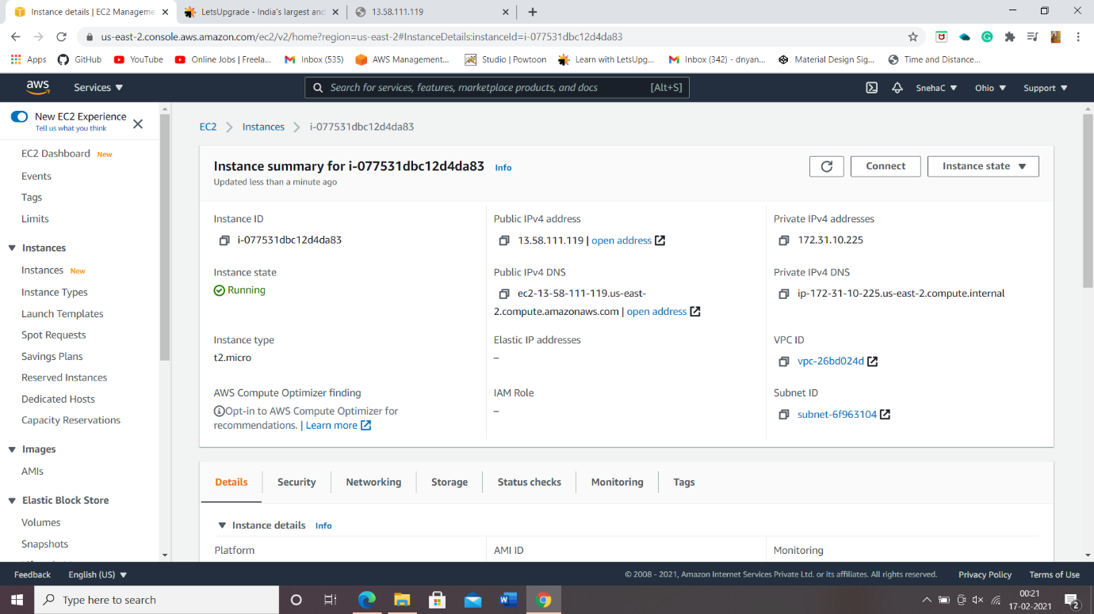

1. Connect then install java and to install Jenkins use following commands:

* sudo wget -O /etc/yum.repos.d/jenkins.repo <https://pkg.jenkins.io/redhat-stable/jenkins.repo>
* sudo rpm --import <https://pkg.jenkins.io/redhat-stable/jenkins.io.key>
* yum install Jenkins.
* extract the password from the location skip installing plugins.

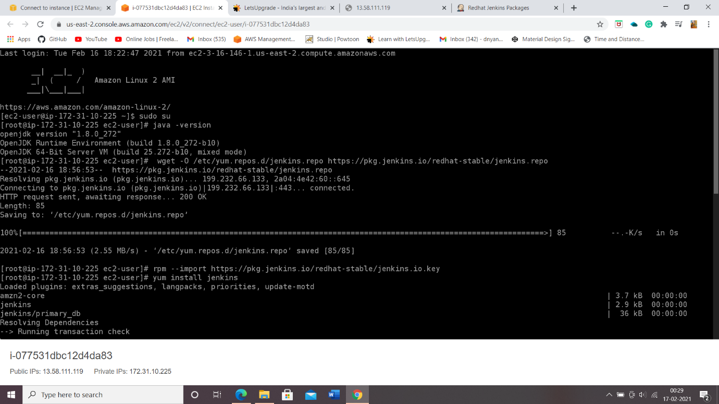

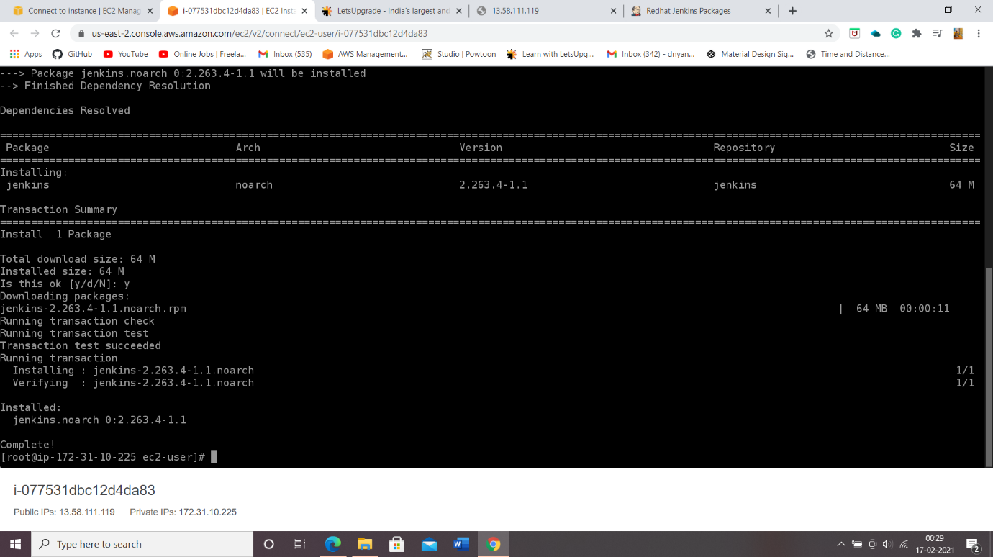

1. Start using Jenkins:

* Change the admin password
* Create a new job
* Build step:execte shell
* echo "hello"
* build the job

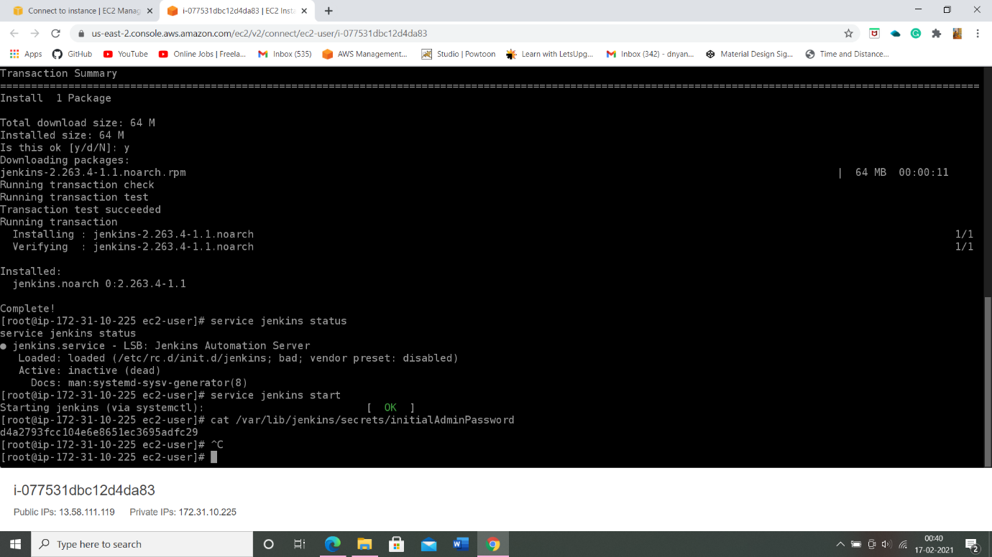

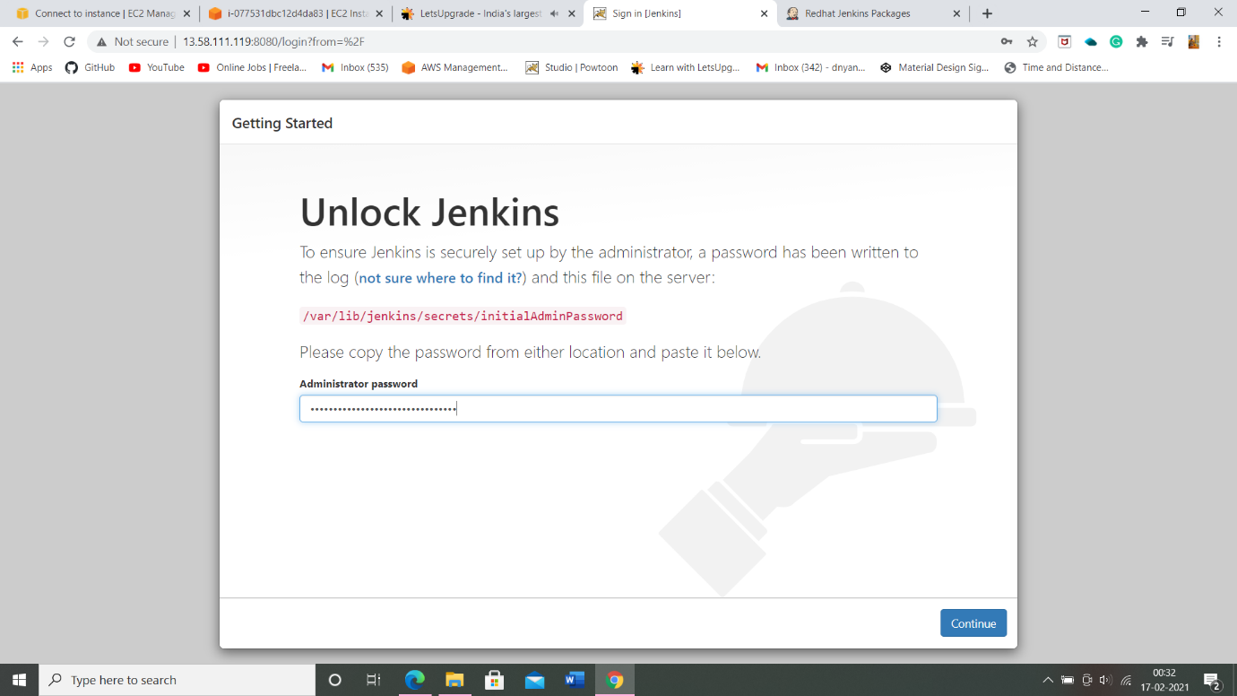

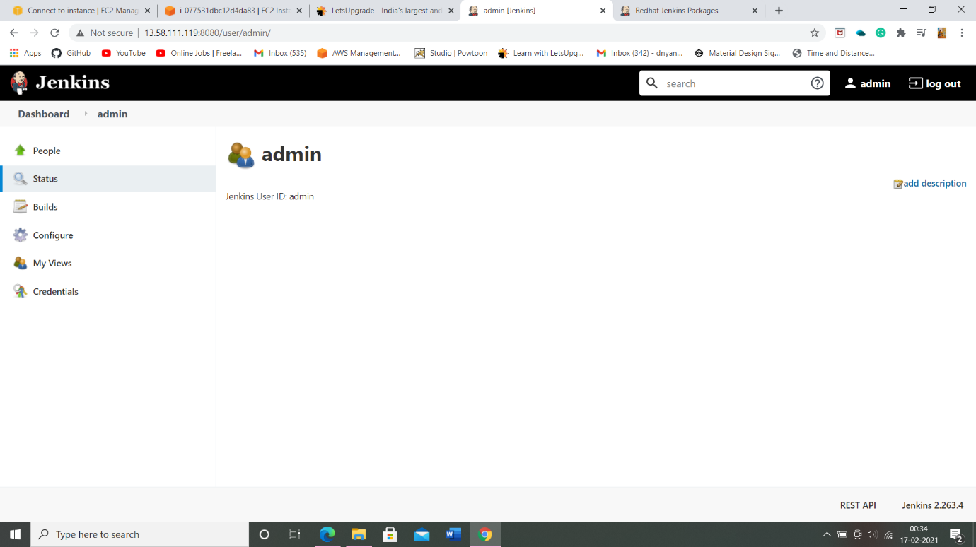

1. Check the output on console:

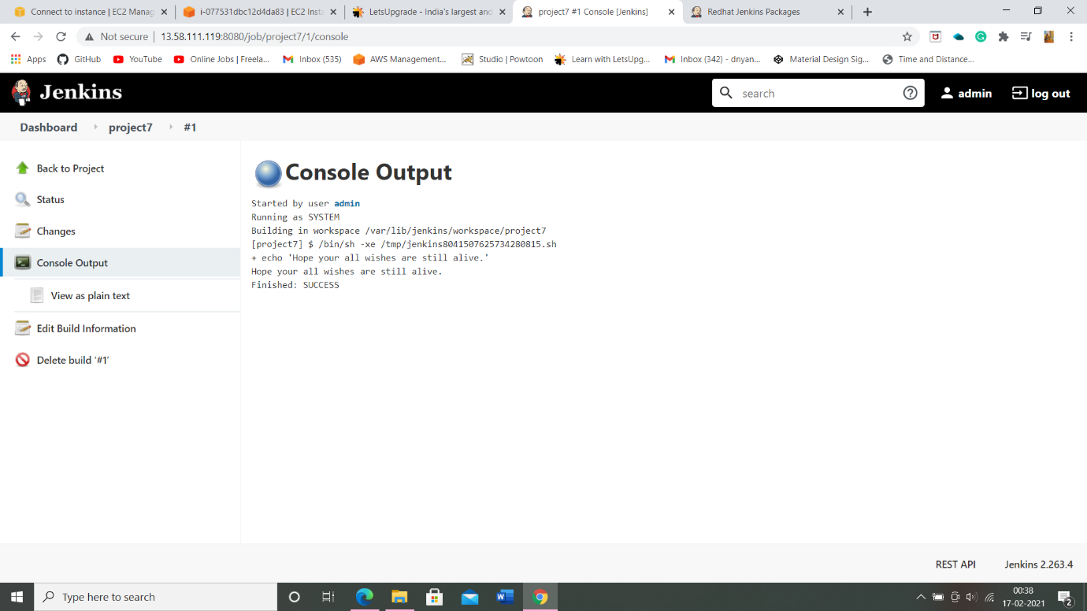

THE ENDss